**Player**

Исходный код проекта:

<https://github.com/verkhoumov/AndroidLabs/tree/master/Player>

Скриншоты экрана:

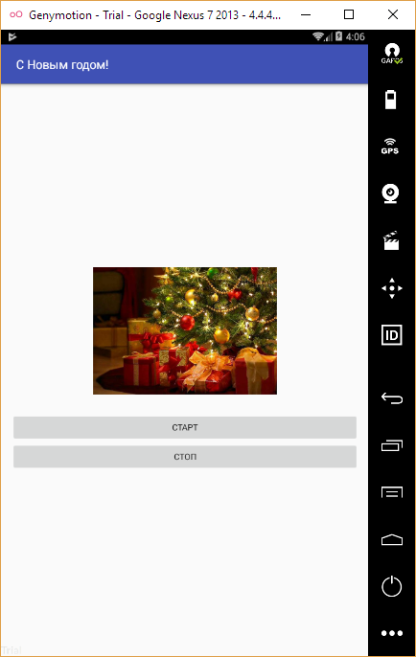

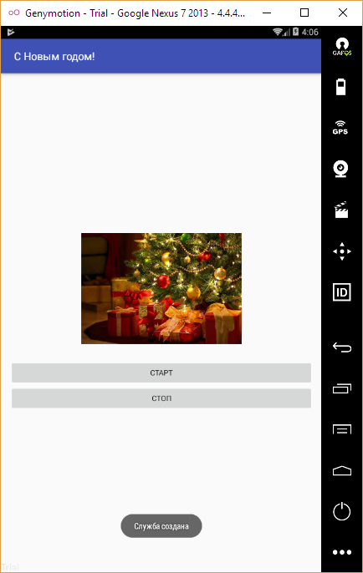

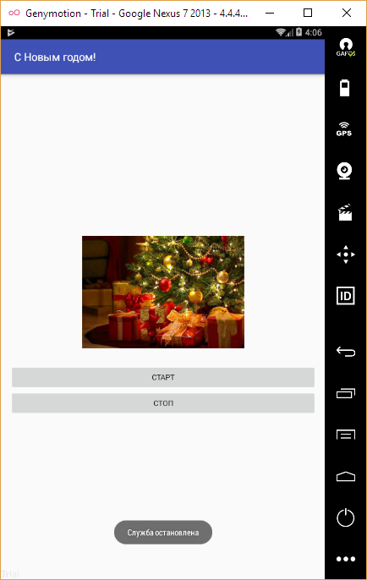

Исходный код.

MainActivity.java:

1. **package** ru.verkhoumov.player;
3. **import** android.content.Intent;
4. **import** android.support.v7.app.AppCompatActivity;
5. **import** android.os.Bundle;
6. **import** android.view.View;
7. **import** android.widget.Button;
9. **public** **class** MainActivity **extends** AppCompatActivity {
11. @Override
12. **protected** **void** onCreate(Bundle savedInstanceState) {
13. **super**.onCreate(savedInstanceState);
14. setContentView(R.layout.activity_main);
16. *// Изменяем заголовок.*
17. setTitle("С Новым годом!");
19. *// Ссылки на кнопки управления воспроизведением.*
20. **final** Button startBtn = (Button) findViewById(R.id.startBtn);
21. **final** Button stopBtn = (Button) findViewById(R.id.stopBtn);
23. *// Запуск и остановка воспроизведения.*
24. startBtn.setOnClickListener(**new** View.OnClickListener() {
25. @Override
26. **public** **void** onClick(View view) {
27. startService(**new** Intent(MainActivity.**this**, PlayerService.**class**));
28. }
29. });
31. stopBtn.setOnClickListener(**new** View.OnClickListener() {
32. @Override
33. **public** **void** onClick(View view) {
34. stopService(**new** Intent(MainActivity.**this**, PlayerService.**class**));
35. }
36. });
37. }
38. }

PlayerService.java:

1. **package** ru.verkhoumov.player;
3. **import** android.app.Service;
4. **import** android.content.Intent;
5. **import** android.media.MediaPlayer;
6. **import** android.os.IBinder;
7. **import** android.support.annotation.Nullable;
8. **import** android.widget.Toast;
10. **public** **class** PlayerService **extends** Service {
11. **private** MediaPlayer mPlayer;
13. @Nullable
14. @Override
15. **public** IBinder onBind(Intent intent) {
16. **return** **null**;
17. }
19. @Override
20. **public** **void** onCreate() {
21. **super**.onCreate();
23. Toast
24. .makeText(**this**, "Служба создана", Toast.LENGTH_SHORT)
25. .show();
27. mPlayer = MediaPlayer.create(**this**, R.raw.new_year);
28. mPlayer.setLooping(**false**);
29. }
31. @Override
32. **public** **int** onStartCommand(Intent intent, **int** flags, **int** startId) {
33. Toast
34. .makeText(**this**, "Служба запущена", Toast.LENGTH_SHORT)
35. .show();
37. mPlayer.start();
39. **return** **super**.onStartCommand(intent, flags, startId);
40. }
42. @Override
43. **public** **void** onDestroy() {
44. **super**.onDestroy();
46. Toast
47. .makeText(**this**, "Служба остановлена", Toast.LENGTH_SHORT)
48. .show();
50. mPlayer.stop();
51. }
52. }

activity_main.xml:

1. <?xml version="1.0" encoding="utf-8"?>
2. <LinearLayout xmlns:android="http://schemas.android.com/apk/res/android"
3. xmlns:tools="http://schemas.android.com/tools"
4. android:layout_width="match_parent"
5. android:layout_height="match_parent"
6. android:paddingBottom="@dimen/activity_vertical_margin"
7. android:paddingLeft="@dimen/activity_horizontal_margin"
8. android:paddingRight="@dimen/activity_horizontal_margin"
9. android:paddingTop="@dimen/activity_vertical_margin"
10. tools:context="ru.verkhoumov.player.MainActivity"
11. android:orientation="vertical"
12. android:gravity="center">
14. <ImageView
15. android:layout_width="wrap_content"
16. android:maxWidth="360dp"
17. android:layout_height="wrap_content"
18. android:id="@+id/imageView"
19. android:src="@drawable/newyear"
20. android:adjustViewBounds="true"
21. android:layout_marginBottom="30dp" />
23. <Button
24. android:layout_width="match_parent"
25. android:layout_height="wrap_content"
26. android:text="Старт"
27. android:id="@+id/startBtn" />
29. <Button
30. android:layout_width="match_parent"
31. android:layout_height="wrap_content"
32. android:text="Стоп"
33. android:id="@+id/stopBtn" />
34. </LinearLayout>